[17. Letter Combinations of a Phone Number](https://leetcode.com/problems/letter-combinations-of-a-phone-number/)

Medium

15.8K

861

Companies

Given a string containing digits from 2-9 inclusive, return all possible letter combinations that the number could represent. Return the answer in **any order**.

A mapping of digits to letters (just like on the telephone buttons) is given below. Note that 1 does not map to any letters.

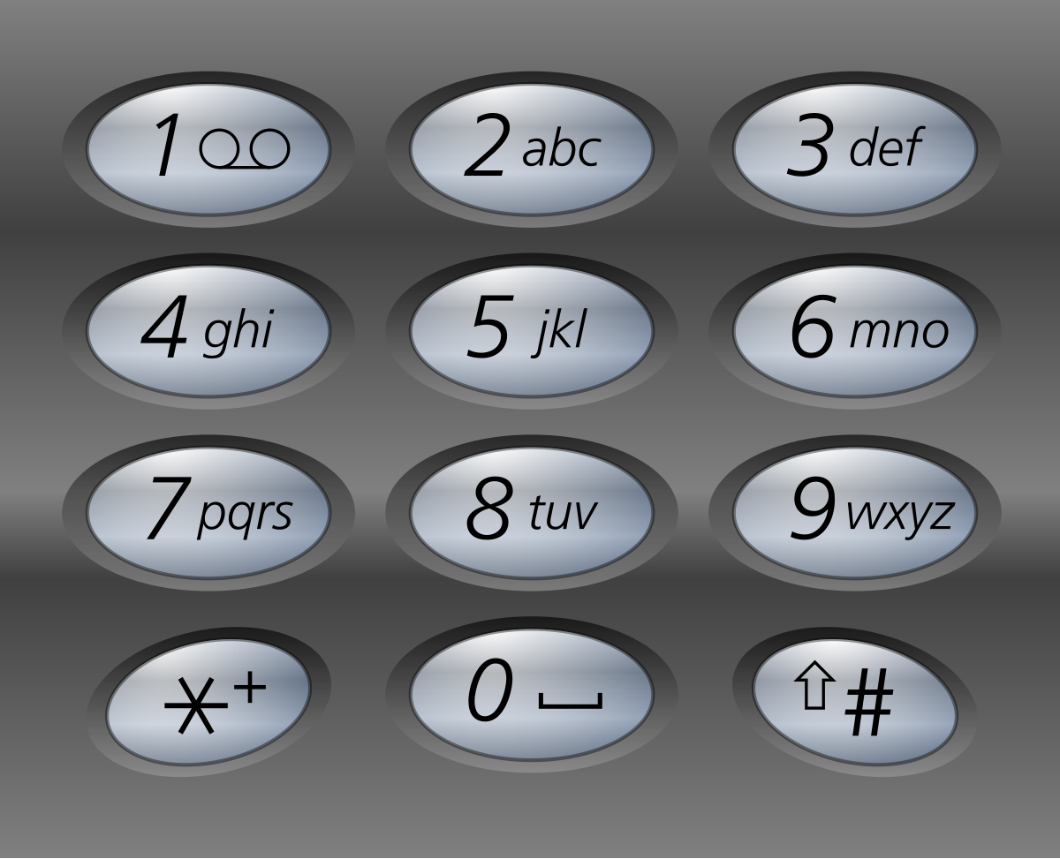

**Example 1:**

**Input:** digits = "23"

**Output:** ["ad","ae","af","bd","be","bf","cd","ce","cf"]

**Example 2:**

**Input:** digits = ""

**Output:** []

**Example 3:**

**Input:** digits = "2"

**Output:** ["a","b","c"]

**Constraints:**

* 0 <= digits.length <= 4
* digits[i] is a digit in the range ['2', '9'].